

**AUTONOMOUS CAR USING LI-DAR**

Aman Saifi, Anirudh Manoj, Ashish Chaudhary

IMS Engineering College, Ghaziabad, U.P. (201015), India.

Department of Electronics and communication.

Email id: - [mr.aman7248@gmail.com id2anirudh@gmail.com chaudharyashish6666@gmail.com](mailto:mr.aman7248@gmail.com%20id2anirudh@gmail.com%20chaudharyashish6666@gmail.com).

**ABSTRACT:**

Our project title is "Autonomous car using LI-DAR". In this project we worked on Autonomous car which is totally self-driven car. It can move one place to another place by avoiding the obstacles on the given path. We have created an automated vehicle which is focused to give automated driving experience to the human driver.

This Autonomous car is capable of sensing the environments, navigating and fulfilling the human transportation capabilities without any need of human input. LIDAR is used for sensing the surroundings. It endlessly tracks the surrounding and if any obstacle is detected then vehicle senses and moves around and avoids the obstacle. The advantages of autonomous cars are fewer traffic collisions, increased reliability, increased roadway capacity, reduced traffic congestion. The main advantages of this project are that as human life has to be secured and safe, efficient, cost-effective and comfortable means of transport.

**INTRODUCTION**

Transportation accidents are in an extremely one amongst the numerous causes of death in the world [1]. According to the report evident by the “World Health Organization (WHO)”, over one million fatalities are caused due to road accidents besides the numbers are even a lot of which integrates very little or major injuries [2]. Most of the time accidents happen because of human errors. Humans attempt mistakes in frequent ways, such as using mobile phones while driving, distracted through billboards and deficiency of sleep results in drowsiness generally while driving [3]. Therefore, in response to the above-mentioned conditions accidents occur [4]. Therefore, there is a need for a solution which helps humans in safe driving [5].

The first guided car was introduced, leading to more enhancement and improvement in cars [6]. Further, the vision guided car was introduced in 1988 with the use of LIDAR and computer vision for tracking and obstacle detection and prevention. For around 20 years, “Uber”, “tesla”, “google”, “Toyota” are some of the manufacturers which have been designing and testing these cars and they had achieved best results while moving towards complete automation [7].

Elsewhere everyday use, self-driving cars could expand transportation options for the elderly and disabled and ease business travel by guiding drivers in unfamiliar locales [8]. Achieving automotive car requires artificial intelligence to process and integrate data from a suite of sensors including UV sensor, laser lidar, LCD and a mobile camera installed with Droid Cam to view the surroundings [9]. Every sensor in the suite has its strengths and weaknesses. Ultrasonic are good at sensing nearby objects, but too short-ranged for driving [10]. Therefore, The Lidar sensor give the full accuracy in detecting the obstacles more accurately other than UV sensors. Also, the cameras are installed to show the local environment for patrolling and spying the environment to help also as the safety measure and protection for the passengers sitting in the autonomous [11].

Independence, where time spent commuting will be time spent doing what you want to do and where deaths from traffic accidents (over 2 million worldwide every year) will be reduced dramatically, since 94% of the accidents are due to human error [12].

Autonomous vehicles/car don’t drink alcohol nor take drugs, these vehicles are never tired or sick, they never take medicines, they never lose their concentration or talk by phone, they know how to drive since the first moment and don’t need to learn, they never act recklessly while driving. On the other hand, they will drive much more smoothly, they will pollute less and, if they have an accident, they will ask for help autonomously.

**3. DIAGRAM**

When Car start Lidar and Colour Sensor send their input to microcontroller. With the received information from Sensors, microcontroller decide to take next decision like Start, Stop, Move Forward, Move Backward, Turn Right, Turn Left, etc. Microcontroller end instruction to the motor driver for controlling motors with respective input taken from sensor. Regulated power supply is connected to the microcontroller as well as motor driver.

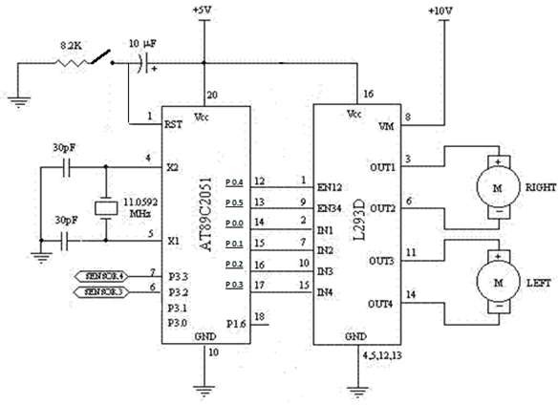

Figure 2.1: Block Diagram of Autonomous Car Using Li-Dar.



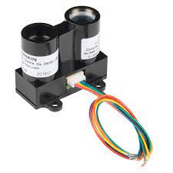**4. HARDWARE USED**

For making the system successful, design implementations play an important role. The components

required to execute this system are briefly described below.

* **Li-Dar**
* A typical lidar sensor (GP2Y0A21YK0F) emits pulsed light waves into the surrounding environment.
* These pulses bounce off surrounding objects and return to the sensor.
* The sensor uses the time it took for each pulse to return to the sensor to calculate the distance it travelled.

|  |  |  |  |  |
| --- | --- | --- | --- | --- |
| **Long Range radar** | **Ultrasound** | **Short/medium range**  **radar** | **Optical Cameras**  **communication** | **Lidar** |
| Microwave radar at 77Ghz has low resolution.  Radar takes more time to lock on an object.  Radar has a wider beam range (Over 50ft Diameter). | Short range, but that makes it the best choice for identifying close objects,  particularly for parking. Used in some parking assists systems today. Also, it spots the people close to the cars. | It cannot distinguish and resolve multiple targets which are very close like our eye. It cannot recognize colour of the targets. Radar takes more time to lock on an object. | The OCC technology does not support high data rate communication. This is due to low frame rates supported by traditional cameras. Image sensors support frame rate of about 30 fps. | Lidar has better accuracy and precision, which allows it to detect smaller objects.  create 3D images based on the high-resolution image. Greenlight (infrared wavelength of 532nm) from Lidar sensors can penetrate water the best and farthest due to its wavelength. |

* **UV sensor**

* As the name suggests, ultrasonic waves are used in this sensor. Also known as HC SR-04 ultrasonic sensor.
* An Ultrasonic sensor is a device that can measure the distance to an object by using sound waves.
* 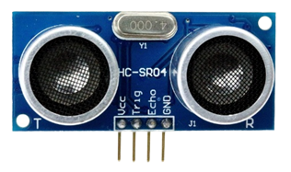It measures distance by sending out a sound wave at a specific frequency and listening for that sound wave to bounce back.
* By recording the elapsed time, the distance is calculated.
* **Arduino UNO**
* Arduino is an open source electronics community.
* It focuses on using microcontrollers in advance electronics by building microcontroller boards.
* These boards use AVR series microcontrollers for processing and controlling.
* You can blink an LED or control a servo motor or even send or receive your twitter messages.

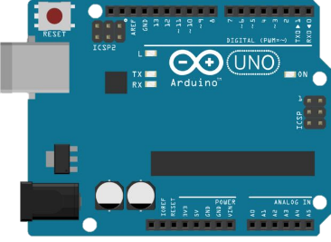

* **Motor Driver module**
* High operating voltage, which can be up to 40 volts;
* Large output current, the instantaneous peak current can be up to 3A;
* With 25W rated power;
* Two built in H-bridge, high voltage, large current, full bridge driver, which can be used to drive DC motors, stepper motors, relay coils and other inductive loads.
* Using standard logic level signal to control.
* Able to drive a two-phase stepper motor or four-phase stepper motor, and two-phase DC motors.

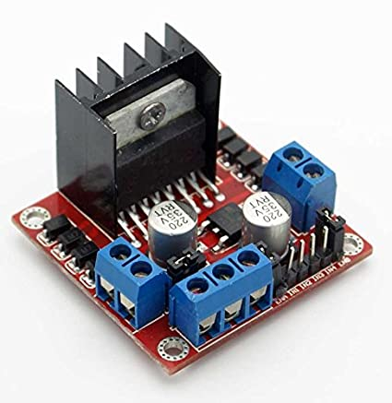





* **DC Motor**
* A motor is an electrical machine which converts electrical energy into mechanical energy.
* 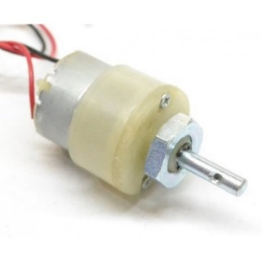The principle of working of a DC motor is that "whenever a current carrying conductor is placed in a magnetic field, it experiences a mechanical force.
* Electrical motors are everywhere around us. Almost all the electro-mechanical movements we see around us used them,
* Additional sensors and electronics control the dc motors.
* **Battery**
* Min Capacity: 2450 mAh.
* 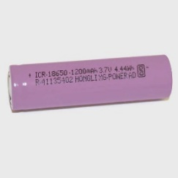Typical Capacity: 2600 mAh.
* Nominal Voltage: 3.7V.
* Charging: CC/CV, Std. 1750mA, 4.20V.
* Charging Time: 3hrs.
* Ambient Temperature.
* Charge: 0～+45°C.
* Discharge: -20～+60°C.
* 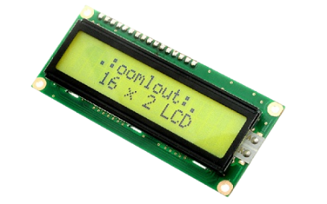**LCD 16X2.**
* The utilization of current is 1mA with no backlight.
* It includes two rows where each row can produce 16-characters.
* The operating voltage of this LCD is 4.7V-5.3V
* These are obtainable in Blue & Green Backlight
* Pin15 (+ve pin of the LED): This pin is connected to +5V
* Pin 16 (-ve pin of the LED): This pin is connected to GND.
* **Atmega328p:**

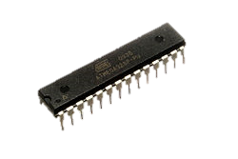

* Arduino/Genuine Uno is a microcontroller board based on the ATmega328p
* It has 14 digital input/output pins (of which 6 can be used as PWM outputs).
* 6 analog inputs are also available for input or output.
* Atmega328p runs at a 16 MHz clock cycle.

**5. WORKING OF PROJECT**

When we switch on the car then Lidar and UV sensor get activated and sent pulse light beam aimed at an object and a sensor looks for its reflection. If beam is detected its intensity and angle is measured. There values are then plugged into an equation run by a microcontroller Atmega 328p.

Simultaneously, UV Sensor from both left and right also emits light from a transmitter, and then detects the light reflected back from the detection object with a receiver.

Their output values are also plugged into microcontroller Atmega 328p. With the help of outputs and value provided by Lidar and UV sensor. Microcontroller instruct the vehicle for start, Stop, Move Forward, Slow Down, Turn Left and Right. Microcontroller Provide command to Motor Driver IC for Controlling Motors of a Vehicle and also the Lidar and both UV sensor measure the distance and show the output on the LCD. Also, the mobile placed over the robot helps in patrolling.

**6. NEED OF PROJECT**

In this modern age there it needs to be defined on which time scope the review addresses. While the technological development is already making progress, the adoption of self-driving cars is just beginning. There are plenty of scenarios on how the route towards a large-scale use of AVs will look like, with technological, societal, legal and economic barriers.

The traffic situation in India leads to design this project prototype, which aims at relaxing driver and creating an automated vehicle whose destination is dynamic unlike Google car, whose destination is static and fixed. This research has been a need for India if implemented in real time.





**7. FLOW CHART**

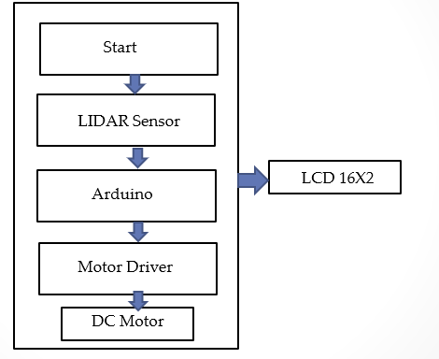

**7.1 APPLICATIONS**

* Spy Robot
* Patrolling Robot.
* For self-driven taxies and Transportation vehicle.
* Distance Measuring Robot.

**7.2 FEATURES**

Autonomous Emergency Braking (AEB) is the most progressive developments for standard safety equipment on autonomous vehicles. This unique technique works by scanning the road ahead and can apply the brakes automatically to avoid a collision. The Vehicle-to-Vehicle (V2V) communication is a technique that wirelessly exchanges information about the speed, position as well as distance of the surrounding vehicles. The technology behind V2V communication allows vehicles to broadcast and receive Omni-directional messages and creates a 360-degree “awareness” of other vehicles in proximity. Light Detection and Ranging (LIDAR) - This technology is used for distance determination and object identification. Standalone mountable units are used on drones as well as road vehicles and many more features.

**8. RESULT & CONCLUSION**

Many drivers are ready for the arrival of self-driving cars, which will cut down on the frustration and irritation of having to constantly pay attention in traffic or on long road trips, among other benefits. This self-driven can also be used as patrol cars, distance measurement at big level, spy robot and many more different and amazing features — including some in our own auto.

The path is still challenging, facing several issues. Awareness of the environment remains the biggest challenge to reliable, smooth, and safe driving. There are number of research questions covering a wide scope that will need to be addressed and answered, including but not limited to customer acceptance, societal impacts, communication technologies, ethical issues, planning, standards, and policy. Software challenges like system security and integrity have also emerged as serious issues to be addressed. These in turn have a number of policy implications including the challenge for policymakers to streamline and regulate many diverse vehicles with different operating constraints. It is also of paramount importance for policymakers to ensure that drivers understand these vehicles’ capabilities and can operate them safely. One of the challenges ahead is to connect several intelligent vehicles to each other and to the infrastructure which gives rise to the application of Big Data, a topic concerned with the processing and analysis of large datasets. In this paper, we shed light on transport related themes that are directly or indirectly and positively and negatively affected by emerging AV technology.



**10. REFERENCES**

[1] Developments in the Last Century, the Present Scenario, and the Expected Future of Autonomous Vehicle Technology. Proceedings of the 12th International Conference on Informatics in Control, Automation and Robotics. Doi:10.5220/0005540501910198.

[2] Thorpe, C., Hebert, M., Kanade, T. and Shafer, S., “Vision and Navigation for the Carnegie Mellon Nav lab”, High Precision Navigation, pp. 97-122, doi:10.1007/978-3-642-74585-06.

[3] Ryan, M., “The Future of Transportation: Ethical, Legal, Social and Economic Impacts of Self-driving Vehicles in the Year 2025”, Science and Engineering Ethics, (2019), doi: 10.1007/s11948-019-00130-2.

[4] Levinson, J., Askeland, J., Becker, J., Dolson, J., Held, D., Kammel, S. and Thrun, S., “Towards fully autonomous driving: Systems and algorithms”, 2011 IEEE Intelligent Vehicles Symposium (IV), (2011), doi:10.1109/ivs.2011.5940562.

[5] Dethe, S. N., Shevatkar, V. S. and Bijwe, R. P., “Google Driverless Car”, International Journal of Scientific Research in Science, Engineering and Technology, (2016).

[6] Asvadi, A., Premebida, C., Peixoto, P. and Nunes, U., “3D Lidar-based static and moving obstacle detection in driving environments: An approach based on voxels and multi-region ground planes”, Robot, Auton. Syst., vol. 83, (2016), pp. 299-311.

[7] Zhao, G., Xiao, X., Yuan, J. and Ng, G. W., “Fusion of 3D-LIDAR and camera data for scene parsing”, J. Vis. Commun. Image Represent, vol. 25, (2014), pp. 165-183.

[8] Moosmann, F., Pink, O. and Stiller, C., “Segmentation of 3D lidar data in non-flat urban environments using a local convexity criterion”, In Proceedings of the 2009 IEEE Intelligent Vehicles Symposium, Xi’an, China, (2009) June 3-5, pp. 215-220.

[9] Park, H., “Implementation of Lane Detection Algorithm for Self-driving Vehicles Using Tensor Flow”, In book: Innovative Mobile and Internet Services in Ubiquitous Computing, pp. 438-447, DOI: 10.1007/978-3-319-93554-6_42

[10] Shao, F., Wang, X., Meng, F., Rui, T., Wang, D. and Tang, J., “Real-Time Traffic Sign Detection and Recognition Method Based on Simplified Gabor Wavelets and CNNs. Sensors”, (2018), Doi: 10.3390/s18103192.

[11] Research on traffic sign detection algorithm based on deep learning [Quan Wang Weiping Fu First published: 03 August 2018] <https://doi.org/10.1002/cpe.4675>.

[12] Wu, B., Iandola, F., Jin, P. H. and Keutzer, K., “SqueezeDet: Unified, Small, Low Power Fully Convolutional Neural networks for Real-Time Object Detection for Autonomous Driving”, IEEE Conference on Computer Vision and Pattern Recognition Workshops (CVPRW), (2017), DOI: 10.1109/CVPRW.2017.60.

[13] Kelly, A., “Mobile Robotics”, Cambridge University Press: New York, NY, USA, (2013)